Name:………………………………………………………………………………………… Date:………………………………Place……………………………………………………..

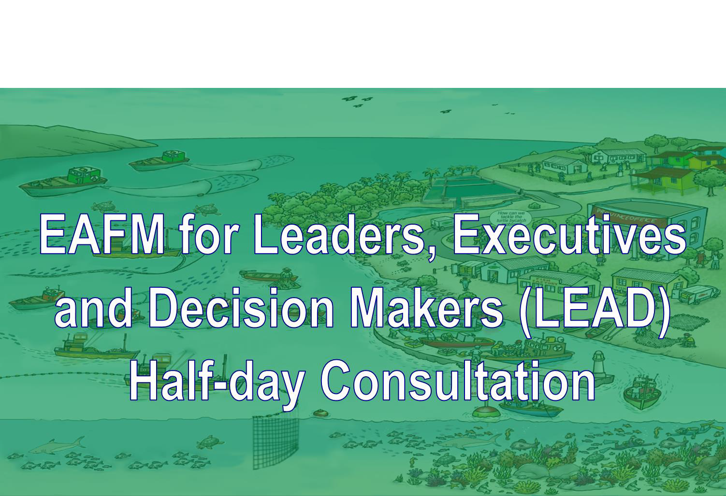
Version 1

☺ How to use this booklet

You will work in groups for much of this course, and you will mostly be using cards, pens and paper for group work. It is USEFUL to you record the outputs from your group work for later reference. Use the relevant sections of this booklet to write your notes.

Module number | Activity/group work | Booklet page number
II | Threats, issues and vision for the future | 3
IV | How much EAFM are you already doing? | 4
IV | Linking policies to action | 5
V | EAFM planning process | 6
VI | Policy trade-offs | 7
VII | Governance structure | 8
VIIIa | What you can do to promote EAFM | 9
VIIIb | What you agency can do to promote EAFM | 10
VIIIc | What your country can do to promote EAFM | 11
VIIId | Next steps (What/How/When/Who) | 12

- List the threats and issues for your fisheries and add key words of the vision for the future.
Threats and issues

Agreed vision key words

LEAD Resource Booklet
III.
What and why of EAFM: How much EAFM are you already doing. Complete this table for your national

To what extent are EAFM principles being applied in your fishery? Plot your fishery on a scale of 0-5 (where 0 = none; and 5 = excellent)

EAFM principles | 0 ………………………………………………………………………………..………………...…5
1. Good governance | …………………………………………………………………………………………..>
2. Appropriate scale | ………………….……………………………………………………………………….>
3. Increased participation | ……………………………………………………………………………………………>
4. Multiple objectives | ……………………..…………………………………………………………………….>
5. Cooperation and coordination | ……………………………………………………………………………………………>
6. Adaptive management | ……………………………………………………………………………………………>
7. Precautionary approach | ……………………………………………………………………………………………>

4

  - Fill in examples of the link between policy – plans – management actions.

Plans - Linking policy to management actions

  - EAFM Planning Process
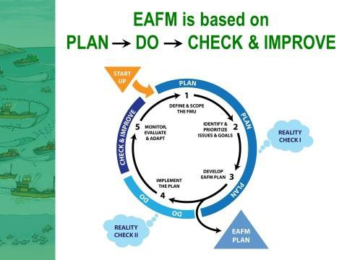

Your role in the planning process

  - Policy trade-offs

Examples of policy trade-offs and mismatches among policies

  - Governance structures

How existing governance structure can be strengthened

VIIIa. Fill in what you, as a LEADer, can do to promote EAFM

What you can do to promote EAFM for staff

VIIIb. Fill in what your agency can do.

What your agency can do to promote EAFM for higher LEADers

VIIIc. Fill in what your country can do to promote EAFM

EAFM for LEADers across sectors

VIIId. Fill in the next steps of actions to promote EAFM

Next steps
 | What | How | When | Who

